Supervised Learning Models and Performance Enhancement Methods Based on Mobile Phone Price Range Prediction
Presentation Link: https://youtu.be/J5X4Q2v9grM
Abdurrahim Gün
Department of Artificial Engineering
a.gun@etu.edu.tr

Abstract - Machine learning is learning a system without explicit programming, with or without data, of the relevant model. There are basically 3 types of learning depending on whether there is data or not and whether the data is labeled or not. In supervised learning, the model is trained with labeled data. Supervised learning models can be used for classification or regression problems. Within the scope of this report, will be examined which supervised learning model gives more successful results for phone price range prediction and how the performance of the most successful model can be improved.

Keywords— Classification Problem, ML, Feature Extraction, Supervised Learning, Pre-Training.

I. INTRODUCTION
ML is a form of AI technology that allows a system to learn on its own without the need for explicit programming [1]. It is mostly concerned with computer design. Data access programs that allow data to learn on its own. This technique begins with data assessment and searches in order to make better decisions [2].

ML approaches can be applied based on the algorithm procedure. There are four types of machine learning approaches: supervised ML techniques, unsupervised ML techniques, semi-supervised ML techniques, and unsupervised ML techniques approach, as well as reinforcement ML techniques [3], [4]. Supervised ML approaches forecast occurrences by using what it has learned from prior and current data with the use of labels. Beginning with the dataset training procedure, ML develops an inferred function to predict the output values. With an adequate training process, the system is capable of producing results to input data. The ML algorithm compares the achieved results to the expected and actual outcomes to discover flaws and adjust the model based on the results. When the training data is not classed or labeled, unsupervised ML approaches are used. It investigates how the system might deduce a function to describe the unlabeled data's hidden patterns. The system does not identify the correct output, but it discovers the data and writes observations from the dataset in order to locate hidden patterns in unlabeled data. Semi-supervised ML techniques are intermediate between supervised and unsupervised ML techniques in that they use labeled and unlabeled data for training. In general, it takes into account a lesser amount of labeled data and a bigger amount of unlabeled data. These techniques can be adjusted to achieve greater precision. It is preferred when the acquired labeled data requires skilled and sufficient resources to train or learn from. In the remaining circumstances, the obtained unlabeled data does not necessitate the use of additional resources. Reinforcement ML approaches use actions to engage with the environment and locate faults or rewards. Some of the common characteristics of the reinforcement strategy include trial and error search and delayed rewards. It helps systems and software programs to find the optimal behavior in a given scenario in order to improve performance.

It is important to choose the model of the appropriate learning type according to the problem. If the model needs to be trained with the available data, the characteristics of the data should be carefully and well analyzed. The reason for this situation is that unlike deep learning, in machine learning, attribute engineering should be done by the model builder. Deep learning models do not require this because the model can do this process within itself because it has many layers. In order to do feature engineering well, the data should be analyzed well. Relevant visualizations should be made for the data. In this way, data analysis will be easier. Various methods can be used in feature extraction. In order to remove any attribute from the data, the correlation between it and the desired output can be examined, if the data space is to be reduced, new attributes can be created by combining the attributes with each other, and pre-training can be done if not all of the existing data is labeled, outlier values can be removed from the data. In this way, the performance of the model can be improved. However, the method that should be used to increase the performance of each model differs. ML approaches can be applied based on the algorithm procedure.

Within the scope of this report, a partially labeled and partially unlabelled data set containing information about the price range of mobile phones was used. By performing appropriate visualization operations for the dataset, the data was examined and the correlations between the attributes were examined. Various classification models were trained and the model with the highest performance was determined. In order to improve the performance of the model with the highest performance, the performance results of feature extraction processes (such as PCA and LDA), data cleaning processes (such as outlier extraction, and variance thresholding), and model hyperparameter changes (such as kernel) methods were examined.

II. REVIEW OF SUPERVISED ML APPROACHES
In general, ML approaches are classified as either supervised or unsupervised. There are two types of supervised ML techniques: probabilistic classifiers and linear classifiers.

A. Probabilistic classifiers
To categorize data, this classifier employs mixture models [5]. It considers each class to be a component of the combination. Every mixture element is a generic model that allows you to sample a specific term of the element. This type of classifier is known as a generative classifier. The most common types of probabilistic classifiers are described below.

1) Naive Bayes Classifier (NB): The NB classifier is a simple and extensively used data classification classifier. It computes a class's posterior possibility based on the distribution of words in a document [6]. To eliminate the word position in the document, it basically uses the bag of words (BOW) feature extraction. It applies the Bayes Theorem to determine whether a feature collection fits into a certain label.
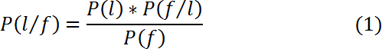
where P (l) is the previous likelihood of a label and P(f/l) is the previous likelihood prior possibility that a particular feature set is labeled. P(f) denotes the previous possibility of a given feature set appearing. NB claimed that each unique characteristic is independent and is represented in Eq.(2)

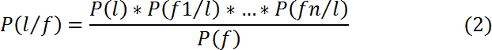

2) Bayesian Network (BN): The non-dependence of the features is a key property of the BN classifier [7], [8]. Another factor to examine is the interdependence of all features. It converts the BN model to a directed acyclic graph, with nodes and edges representing random variables and conditional dependencies. It is expected to be a complete model for the variable and its relationship. As a result, a total joint probability distribution (JPD) for all variables in a model is defined. Because the BN classifier is computationally complex, it should not be used to mine text [9].

B. Linear classifiers
The linear classifier is designed to arrange items with similar feature values into groups. According to Timothy et al. [9], the linear classifier made a classification judgment based on the value of a linear combination of characteristics. The output value for a real vector input will be

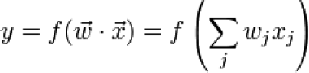 (4)

where denotes a real vector and f is a function that converts
the (.) of two vectors to the desired output.

1) Support Vector Machine (SVM): Introduced in [10], SVM classifies data by constructing an n-dimensional hyperplane that finely separates into two kinds. SVM and NN are significantly connected. In general, an SVM model with a sigmoid kernel function is equivalent to a two-layer Perceptron NN. These models are more akin to classic MLP. With an extra kernel function, SVM may be used to train polynomial RBF and MLP. In the default NN training method, the network weights are set by solving a quadratic programming problem with linear constraints rather than a non-convex, unconstrained minimization problem.

2) Logistic Regression (LR): Logistic regression (LR) [11] is a widely utilized statistical technique for application scoring and credit risk modeling. Some studies have shown that these methods are inefficient and imprecise when compared to modern ML techniques. The logit model is founded on the logistic distribution and its distribution function, as shown in Eq. (5).

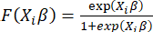 (5)

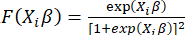 (6)

3) Random Forest (RF): RF [12] method is highly applicable to various classification problems. It is an ML approach that incorporates the processes to aggregate data, bagging, and DT models using subsets. It selects a subset of features from an individual node of the tree with the avoidance of correlation in the bootstrapped set. For a task to classify companies and ratios, RF is a forest of k trees and is computed as

The classification capacity of RF is computed by out-of-bag (OOB) classification error.

C. Other classifiers

1) Gradient Boosting:
Gradient boosting is a machine learning technique that combines multiple weak learners to build a strong predictive model. It is a type of ensemble learning, meaning that it combines the predictions of multiple models to improve overall performance. The basic idea of gradient boosting is to create an ensemble of weak models where each model is trained to predict the residuals of the previous model. The residuals are the errors made by the previous model and represent the part of the data that the previous model failed to predict. The first model in the ensemble is a simple model such as a decision tree. The second model is trained to predict the residuals of the first model. The third model is trained to predict the residuals of the second model and so on. The weights of the models in the ensemble are adjusted to minimize a loss function such as the ensemble mean squared error. The loss function measures the difference between the predicted values and the true values. Gradient boosting has been shown to be effective for a wide range of machine-learning tasks, including classification, regression, and ranking. It is a popular choice for many real-world applications such as fraud detection, spam filtering, and medical diagnostics.

2) k nearest neighbor: The k-nearest Neighbors (k-NN) algorithm is a simple and intuitive machine learning algorithm used for classification and regression tasks. It's considered a non-parametric and instance-based learning method. The fundamental idea behind k-NN is to classify or predict the target variable of a new data point based on the majority class or average value of its k closest neighbors in the feature space.

III. MODEL
While creating the model, the necessary data visualizations were first performed. The data used consists of 2000 labeled and 1000 unlabeled data. Figures 1 and 2 show the correlation matrix of the attributes in the labeled and unlabeled data.
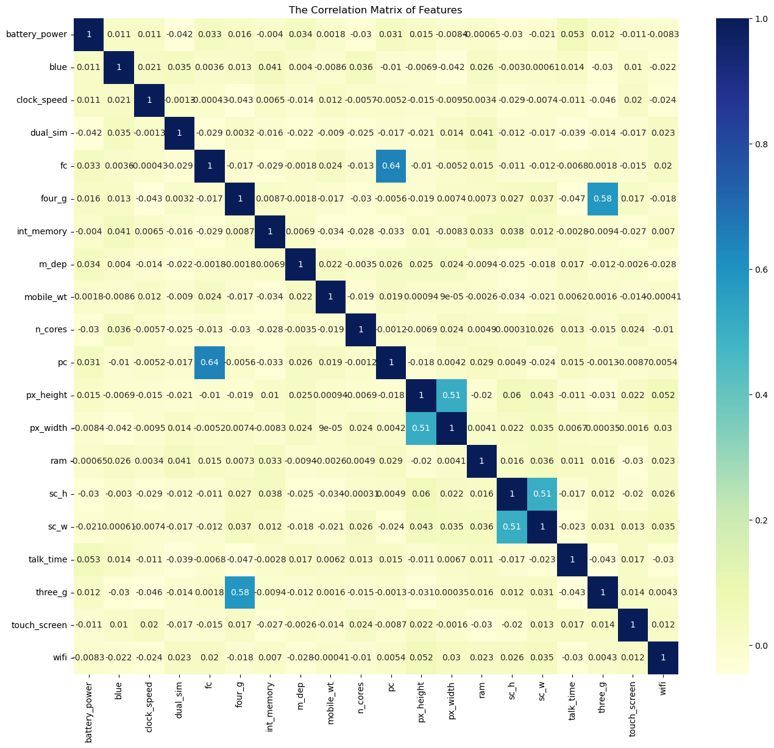
Figure 1: Correlation Matrix of Labelled Data

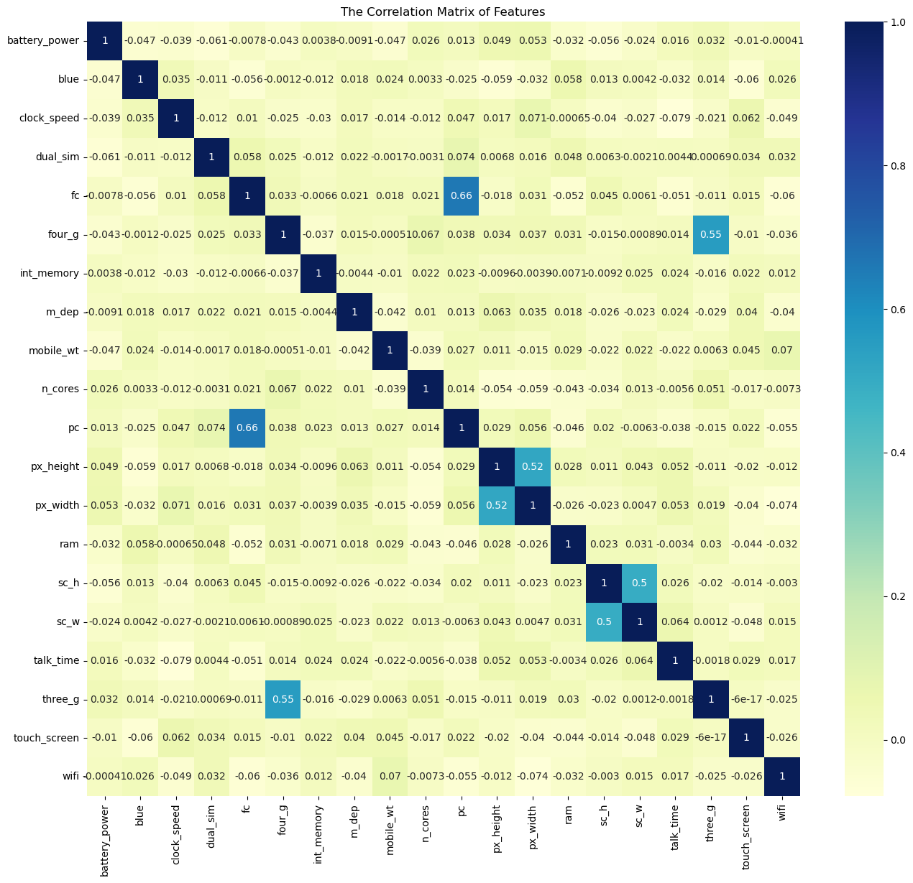
Figure 2: Correlation Matrix of Unlabelled Data

As can be seen from the correlation matrices, the correlation values between the attributes in the unlabelled data and the correlation values between the attributes in the labeled data are close to each other. In this case, it can be concluded that unlabelled data can be used in the pre-training process.

Within the scope of this study, firstly, which model shows the highest performance for the problem to be solved was analysed. For this purpose, various models were tried, and it was concluded that SVM was the best-performing model without any attribute processing and pre-training.

In the second stage, the problem of how to increase the 97% accuracy value of the SVM model was emphasised. For this purpose, PCA (Principle Component Analysis) and LDA (Linear Discriminant Analysis) feature fusion algorithms were tried. As a result, the PCA method was found to be more successful. It was examined whether the performance of the model could be improved by changing the hyper parameters in the SVM model and it was observed that the best kernel was the "linear" kernel. Then data normalisation was tried but this process decreased the performance of the model. After this process, a random forest model was trained to see which attributes were the most important and the model was trained according to these attributes. However, this process also decreased the model performance. Variance thresholding and z-score based thresholding algorithms were tried to remove outlier values in the data. It was observed that both methods were successful in eliminating outlier values and it was concluded that the performance of the model increased when the model was trained after these values were removed. The outlier elimination and PCA procedures were used together and the performance of the model was improved to achieve 98% accuracy. Finally, the pre-training process was tried with unlabelled data and it was observed that the accuracy value was 98% as a result of this process. As a result, the SVM training method was chosen after preprocessing with unlabelled data since it provides faster training for the data set under study. It was aimed to compare the performance of the model with that of a deep learning model. However, since the size of the data set was not large enough, the classification part was done with a machine learning model. Since the best performing model was found to be SVM, SVM was used as the classification model. Deep learning was used for the pre-training part. For this, autoencoder model was used. Accuracy value of 98.5% was obtained.

IV. CONCLUSION
As a result of the study, SVM was found to be the model that performed the best classification process in the data set used. The importance of feature processing in the training of a machine learning model was observed. It has been observed that each method does not always work with the same performance and can be found by trial and error according to the problem. It has been realized that deep learning is not always the best way and that it gives bad results when the number of data is low. For this reason, it was seen that machine learning can work as well as deep learning if the data set is well-examined and the necessary operations are done correctly.

REFERENCES
- A. Holzinger, H. Plass, K. Holzinger, G.C. Crisan, C.M. Pintea, C. M., and V. Palade, “A glass-box interactive machine learning approach for solving NP-hard problems with the human-in-the-loop,” arXiv preprint arXiv:1708.01104.
- I.H. Witten, E. Frank, M.A. Hall, and C.J. Pal, “Data Mining: Practical machine learning tools and techniques,” Morgan Kaufmann. 2016.
- A.K. Jain, M.N. Murty, and P.Flynn, “Data clustering: a review,” ACM Comput Surveys, vol. 31, no. 3, pp. 264–323, 1999.
- M. Dutton and G.V. Conroy, “A review of machine learning,” The Knowledge Engineering Review, vol. 12, pp. 341-367, 1997.
- J. Friedman, T. Hastie, and R. Tibshirani, “The elements of statistical learning,” New York: Springer series in statistics, vol. 1, pp. 337-387, 2001.
- N. Friedman, D. Geiger, and M. Goldszmidt. “Bayesian network classifiers,” Machine learning, vol. 29, pp. 131-163, 1997.
- F. Jensen, “An introduction to Bayesian networks”. Vol. 210. London: UCL press, 1996.
- C.C. Aggarwal, and C. Zhai, “A survey of text clustering algorithms,”
In Mining Text Data, pp. 77-128, 2012.
- Shepard, P. J. “Decision Fusion Using a Multi-Linear Classifier,” Proceedings of the International Conference on Multisource-Multisensor Information Fusion, 1998.
- L. Gonzalez, C. Angulo, F. Velasco, and A. Catala, “Unified dual for
bi-class SVM approaches,” Pattern Recognition, vol. 38, no. 10,
pp.1772-4, 2005.
- S.S.Haykin, “Neural networks and learning machines,” Vol. 3. Upper Saddle River, NJ, USA:: Pearson, 2009.
- L. Breiman, “Random Forests Machine Learning,” View Article PubMed/NCBI Google Scholar, pp. 45-32, 2001.
- R. Saravanan, Pothula Sujatha, A State of Art Techniques on Machine Learning Algorithms: A Perspective of Supervised Learning Approaches in Data Classification, 2018.

